 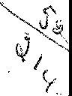



CRYSTAL CREEK

,_*<* DECLARATION OF COVENANTS, CONDITIONS RESTRICTIONS, EASEMENTS AND LIENS

Prepared By:

#### 8£:: Ed 9l 8Jci S6.

RHEIN-MEYER PARTNERSHIP NO. I

7265 Kenwood Road, Suite 157

Cincinnati, Ohio 45236

 



TABLE OF CONTENTS

BOO 597,.I,' 581

ITEM PAGE NO

INTRODUCTION I

ARTICLE I 2

Definitions 2

1.1 Definitions. 2

ARTICLE II 4

Annexation. 4

* 1. Annexation of Additional Property 4
  2. Procedure. 4

ARTICLE Ill 5

Property Rights 5

* 1. Owner's Right of Enjoyment 5
  2. Title to Common Areas 5

ARTICLE IV 6

Association Membership and Voting Rights 6

* 1. Members 6
  2. Classes and Voting Rights. 6

ARTICLE V 7

Assessments 7

* 1. Covenant for Assessment. 7
  2. Purpose of Assessments 7
  3. Annual General Assessments 7
  4. Special Assessments 8
  5. Individual Assessments 8
  6. Basis and Apportionment of Assessments 8
  7. Commencement of Assessments 8
  8. Assessments Certificates 9
  9. Non-Payment of Assessments 9
  10. Subordination of Lien to First Mortgage ...........................1O

ARTICLE VI. 11

Maintenance 11

* 1. Maintenance of Common Lots 11
  2. Reserves 11
  3. Professional Management Contracts. 11
  4. Maintenance of Storm Drainage\ 11

Detention Basin Easements

* 1. Maintenance of Fence And Landscape 11

Easement (Lots 2 through 5)

eoov 597 P,G' 5E2

TABLE OF CONTENTS

ITEM PAGE NO.

ARTICLE VII 12

Insurance 12

7.1 Fire, Extended Coverage and Standard "All Risks" 12

7.Use of Fire Insurance Proceeds 12

* 1. Liability Insurance 12
  2. Other Insurance 13

7.Insufficient Insurance 13

7.6Fidelity Bonds 13

ARTICLE VIII. 14

Use Restrictions. 14

###### 8.1 ........................................................ 14

8.Enforcement 14

1. P3rohibited Uses 14

ARTICLE IX 17

Miscellaneous 17

9.Duration 17

1. A2mendment. 17

9.Personal Liability 17

* 1. Notices. 18
  2. Enforcement. 18
  3. Severability 18

97.Conflicts 18

9.Rights of Mortgage Holders 18

9.C9

ondemnation 19

ii

CRYSTAL CREEK  DECLARATION OF COVENANTS, CONDITIONS,

RESTRICTIONS, EASEMENTS AND LIENS

THIS DECLARATION, made this *'3o'"'* day of j"' "'•r;z ,1995, by RHEIN­ MEYER PARTNERSHIP NO. I, an Ohio General Partnership, hereinafter called "Declarant", WITNESSETH:

WHEREAS, the Declarant is the owner of the real property described in Exhibit "A" hereof and desires to create thereon a residential community with Common Areas for the benefit of said community; and

WHEREAS, the Declarant desires to provide for the preservation of the values and amenities in said community and for the maintenance of entrance features and the Common Areas within said community; and to this end, desires to subject the real property described in Exhibit "A" hereof to the covenants, restrictions, easements, charges and liens, hereinafter set forth, each and all of which is and are for the benefit of said property and the subsequent owners thereof; and

WHEREAS, the Declarant has deemed it desirable, for the efficient preservation of the values and amenities in said community, to create an association to which should be delegated and assigned the powers and duties of maintaining and administering the entrance features and Common Areas and administering and enforcing the within covenants and restrictions and disbursing the charges and assessments hereinafter created; and

WHEREAS, the Declarant has formed Crystal Creek Homeowners' Association as a non-profit Ohio Corporation for the purpose of carrying out the powers and duties aforesaid;

NOW, THEREFORE, the Declarant hereby declares that all of the property described in Exhibit "A", and such other property as may be subjected to the provisions hereof pursuant to Article II, shall be held, sold and conveyed subject to the easements, restrictions, covenants, conditions and liens set forth in this Declaration and any subdivision plat which includes the property, which are for the purpose of protecting the value and desirability of, and which shall run with, the property and be binding on all parties having any right, title or interest in the described Property or any part thereof, their heirs, successors and assigns, and shall inure to the benefit of each owner thereof.

ARTICLE I  DEFINITIONS

Section 1.1. Definitions. The following terms when used in this Declaration have the following meanings:

A "Articles" and "Articles of Incorporation" shall mean those articles, filed with the Secretary of State of Ohio, incorporating the Crystal Creek Homeowners' Association, as a corporation not-for-profit under the provisions of Chapter 1702 of the Revised Code of Ohio, as the same may be amended from time to time. A true copy of the Articles as shown in Exhibit "D" is attached hereto and made a part hereof.

8. "Association" shall mean and refer to Crystal Creek Homeowners' Association, and its successors and assigns.

1. "Board" and "Board of Trustees" mean the Board of Trustees of the Association as provided in the Articles of Incorporation and By-Laws of the Association.
2. "By-Laws" means the By-Laws or Code of Regulations of the Association, as the same may be amended from time to time, pursuant to Section 1702 of the Revised Code of Ohio. A true copy of the By-Laws as shown in Exhibit "C" is attached hereto and made a part hereof.
3. "Common Areas" shall mean and refer to all Open Space and other real property, including structures thereon, owned by the Association for the benefit, use and enjoyment of its Members.
4. "Declarant" shall mean and refer to Rhein-Meyer Partnership No. I, an Ohio General Partnership, its successors and assigns.
5. "Developer" shall mean and refer to Rhein-Meyer Partnership **No.** I, and such other persons and entities as may acquire one or more lots from the Declarant for the purpose of constructing improvements thereon for resale, but only to the extent of such lots acquired.
6. "Living Unit" shall mean and refer to any portion of a building situated upon the Property designed and intended for use and occupancy as a residence by a single family.



###### "Lot" shall mean and refer to any plot of land shown upon any recorded subdivision plat of the Property with the exception of land designed by Declarant to be conveyed to the Association as Common Areas.

1. "Member" shall mean any one of those Owners who are members of the Association as provided in its Articles of Incorporation.
2. "Owner" shall mean and refer to the record owner, whether one or more persons or entities, of a fee simple title to any Lot which is a part of the Property, including purchasers on land installment contract as defined in Ohio Revised Code Chapter 5313, and including contract sellers on other forms of executory contracts for the sale of a Lot, but excluding those having such interest merely as security for the performance of an obligation.
3. "Property" shall mean and refer to all of the lots of Crystal Creek subdivision, as described herein, and such additions thereto as may hereafter be annexed pursuant to Article 11.

ARTICLE II

ANNEXATION

Section 2.1. Annexation of Additional Property. The Declarant, its successor and assigns, as owner of said real estate, may annex to this Declaration the real property, or any part thereof, described in Exhibit "B" attached hereto, without the assent of the members of the Association, within ten (10) years after the date this Declaration is filed for record. However, the Declarant is not bound to annex any of said property to this Declaration, and until such time as any of said property is annexed, the same shall not be subject to the provisions of this Declartion. The number of Lots to be included in Exhibits "A" and "B" shall not exceed 100 Lots.

Section 2.2. Procedure. Any annexations made pursuant to Section 2.1 of this Article II, or otherwise, shall be made by recording a supplement to this Declaration with the Recorder of Clermont County, Ohio, which Supplementary Declaration shall extend this Declaration to such annexed property. Such Supplementary Declaration may contain such additional covenants, conditions, restrictions, easements and liens as the Declarant shall deem appropriate for the purpose of completing the development of the Property.

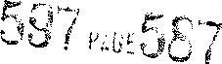ARTICLE Ill

PROPERTY RIGHTS

Section 3.1. Owner's Right of Enjoyment. Every owner and, in the case of rented living units, such owner's tenants, shall have a right to and easement for the enjoyment of, in, and to the Common Areas, and such right and easement shall be appurtenant to and shall pass with the title to every lot, subject to the following:

1. The right of the Association, in accordance with its Articles of Incorporation and Regulations, to borrow money for the purpose of improving the Common Areas, and in aid thereof to mortgage said property. The Association shall not mortgage the Common Areas except by resolution approved by two-thirds (66-2/3%) of the total number of votes held by the owners of each class;
2. The right of the Association to levy annual and special assessments.
3. The right of the Association to grant easements over or to dedicate or transfer all or any part of the Common Areas to any public agency, authority, utility, or other persons or entities for such purposes and subject to such conditions as may be agreed upon by the members. No such grant, dedication or transfer shall be effective unless an instrument approved by two-thirds (2/3) of each class of members agreeing to such grant, dedication or transfer at a meeting called for such purpose has been recorded upon the public records of Clermont County, Ohio;
4. The right of the Declarant, its successors and assigns, or any successor Developer, to make any improvements they deem proper upon the Common Areas, even after their conveyance to the Association.
5. The right of the Declarant, its successors and assigns, and the Association, to erect and maintain signs and landscaping within sign and landscape easements upon lots and within Common Areas as shown upon any plat of subdivision of the Property.

Section 3.2. Title to Common Areas. Title to the Common Areas shall be conveyed to the Association free and clear of all liens and encumbrances; provided, however, that the Declarant shall have the right from time to time to reserve for the purpose of development of the Property all or any portion of the Property for various easements and rights-of-way, together with the right to dedicate same where applicable and customary and the right of ingress and egress across the Common Areas in connection with the development of the Property. The Declarant's rights hereunder shall not unreasonably interfere with the Owners' easement of enjoyment.



ARTICLE IV

ASSOCIATION MEMBERSHIP AND VOTING RIGHTS

Section 4.1. Members. Every Lot Owner shall be a member of the Association, and such membership shall be appurtenant to and may not be separated from ownership of any Lot. The Declarant shall be a member of the Association so long as it qualifies as a Class A or Class B member as defined below.

Section **4.2.** Classes and Voting Rights. The Association shall have two (2) classes of voting membership:

1. Class A - Except as provided below, Class A members shall be all Lot Owners except the Declarant, and Class A members shall be entitled to one (1) vote for each such Lot owned. When more than one (1) person holds an interest in any Lot, all such persons shall be members. The vote for such Lot shall be exercised as the Owners determine, but in no event shall more than one (1) vote be cast with respect to any Lot.
2. Class B - Class B member shall be the Declarant (as defined in the Declaration), and such member shall be entitled to such number of votes as will constitute seventy-five percent (75%) of the total voting power of the Association, so long as the Class B membership continues to exist. The Class B membership shall cease to the extent permitted by Ohio Law and shall be converted to Class A membership with one vote for each Lot owned, on the happening of either of the following events, whichever occurs earlier:
3. When all of the real property described in Exhibit "B" has been annexed to this Declaration by the Declarant and seventy-five percent (75%) of the Lots therein (up to a total of 100 Lots) have been sold by the Declarant and conveyed to individual lot owners;
4. Seven (7) years from and after the date this Declaration is filed for record.

Provided, further, that nothing herein shall be construed to prohibit the Class B member from converting all or part of its Class B membership to Class A membership with the results set forth above at any time earlier than the latter of the alternative events referred to above, by written statement executed by the Declarant and delivered to the Association.



ARTICLE V

ASSESSMENTS

Section 5.1. Covenant for Assessments. The Parties hereto, and each person, group of persons or entity which becomes an Owner of a Lot, whether or not it shall be so expressed in any deed or other conveyance, shall be deemed to covenant and agree to pay the Association: (1) annual assessments; (2) special assessments for capital improvements or other services provided by the Association; (3) individual assessments; and such assessments to be fixed, established and collected from time to time as hereinafter provided. All assessments, together with such interest thereon and costs of collection thereof as hereinafter provided, including, but not limited to, reasonable attorneys' fees, shall be a charge on and shall be a continuing lien upon the Lot and improvements against which such assessment is made. Each such assessment, together with such interest thereon and costs of collection thereof as hereinafter provided, shall also be the personal obligation of the person, group of persons or entity who was the Owner of such property and Lot at the time when the assessment fell due.

Section 5.2. Purpose of Assessments. The assessment levied by the Association shall be used to maintain, promote, protect and enhance the value of the Common Areas.

Section 5.3. Annual General Assessments. An annual general assessment shall be levied on the lots and members owning lots in such amount as determined by the Association to provide and be used for the purpose of: (a) providing grass cutting, fertilizing, weed and insect treatments and maintenance of trees, shrubbery and flowers located on or within Common Areas, Open Space and Landscape Easements; (b) providing maintenance and operation of all walls, irrigation facilities, sidewalks, fences, signage, lighting or other structures and facilities located on or within any of the areas identified as Common Areas, Open Space and Landscape Easements; (c) providing grass cutting, fertilization, weed and insect treatments and maintenance of trees, shrubbery, flowers and sidewalks within the public street right­ of-way where it is adjacent to Common Areas, Open Space and Landscape Easements; (d) providing fire and extended coverage insurance, and vandalism and malicious mischief coverage wherever possible (or such other varieties of insurance as may be agreed to by the Association and the Lot Owners, including the contents thereof), all of such insurance policies shall be payable to the Association as Trustee for the Lot Owners, the Association, and their mortgagees, as their interests may appear, the proceeds of which shall be used to restore or replace any improvements damaged or destroyed by any peril covered by said insurance; (e) real estate taxes and assessments on Common Areas; (f) service charges for sewer, water, electric and other utility facilities serving Common Areas and landscape areas;



1. management, supervision, legal and accounting expenses; (h) providing reasonable reserves for contingencies, replacements, maintenance, repairs, other costs incurred by the Association, and working capital of at least two (2) months' estimated charges for each lot; and (i) other maintenance and repair of Common Areas as further detailed in Section 6.1 and 6.2 of this Declaration.

Section 5.4. Special Assessments. In addition to the annual and individual assessments authorized by this Article, the Association may levy special assessments, for the purpose of defraying, in whole or in part, the cost of any construction or reconstruction, or unexpected repair or replacement, of a capital improvement located upon the Common Areas or Landscape Easements, provided (except in the case of insufficient insurance as set forth in Article VII, Section 7.6) such special assessments shall have the assent of 66-2/3% of the total number of votes held by the Members of each class. A meeting of the Members shall be duly called for this purpose, written notices of which shall be sent to all Members at least fifteen (15) days in advance of such meeting, which notice shall set forth the purpose of the meeting.

Section 5.5. Individual Assessments. In the event that any damage is caused to any of the Common Areas or Landscape Easements through the willful or negligent act of a Lot Owner, his family, tenants, guests or apportionment, the Board shall have the obligation to correct or repair any such damage, and the costs thereof shall be added to and become a part of the assessment against the individual Lot owned by the Lot Owner, or his family, tenants, guests or apportionment causing such damages.

Section 5.6. Basis and Apportionment of Assessments. Both annual general assessments and special assessments, as provided for in Sections 5.3 and 5.4, shall be apportioned equally upon all of the Lots.

Section 5.7. Commencement of Assessments. The annual assessment for each Lot shall commence on the first day of the month following the conveyance of the first Lot by the Declarant. The first annual assessment shall be pro-rated for the calendar year beginning January 1, 199!i An assessment equal to twenty-five percent (25%) of the allocated assessment shall be allocated to unsold Lots owned by the Declarant. In the event the Declarant elects to subsidize the Association, those amounts paid by the Declarant to subsidize the Association shall be credited against annual assessments owed by the Declarant. All assessments shall be payable in advance in equal installments as determined by the Board of Trustees. Failure to mail notices by the dates required shall not affect the rights of the Association to assess Lots as provided herein.

It shall be the duty of the Board of Trustees of the Association to fix the amount of the general assessments applicable to each Lot annually. The Board of



Trustees shall make reasonable efforts to fix such amounts, in advance, by the first day of December of each year, and shall, at that time, prepare a roster of the Lots and assessments applicable thereto, which shall be kept in the office of the Association and shall be open to inspection by any Lot Owner upon reasonable notice to the Board. Written notice of the assessment shall thereupon be sent to the

Owners of any Lot subject thereto. Annual assessments shall become a lien on each *7*

Lot on January 1 of each year. Failure to mail notices by the dates required shall not affect the right of the Association to assess lots as provided herein.

Individual and special assessments shall be fixed by the Board of Trustees as provided in this Article, which assessments shall become a lien on the Lots on the date that the Board mails written notice of any such assessment to the Owners of any Lot subject thereto.

Section 5.8. Assessments Certificates. The Association shall, upon demand, at any reasonable time, furnish to any Lot Owner liable for assessments or to his designee a certificate in writing signed by an officer or other authorized agent of the Association, setting forth the status of said assessments, i.e., whether the same are paid or unpaid and the amount outstanding. Such certificate shall be conclusive evidence of the payments of any assessments therein stated to have been paid. A charge not to exceed Fifteen Dollars ($15.00) may be levied in advance by the Association for each Certificate so delivered.

Section 5.9. Non-Payment of Assessment. Any assessment levied pursuant to these covenants which is not paid on the date when due shall be delinquent and shall, together with such interest thereon and cost of collection thereof, as hereinafter provided, including reasonable attorney's fees, thereupon become a continuing lien which shall bind such Lot in the hand of the then Owner, his heirs, devisees, personal representative and assigns. The personal obligation of the then Owner to pay such assessment, however, shall remain his personal obligation and shall not pass to his successors in title unless expressly assumed by them.

If the assessment is not paid within thirty (30) days after the delinquency date, the assessment shall include a penalty of .Five Dollars ($5.00) per mont.h., and the Association may bring an action at law against the Owner personally obligated to pay the same, or to foreclose the lien against the Lot, in either of which events, interest, costs and reasonable attorneys' fees shall be added to the amount of each assessment. No owner may waive or otherwise escape liability for the assessment herein provided by abandonment of his Lot. To the extent any assessment lien is not paid out of the proceeds of a foreclosure sale, and is discharged, the amount thus unpaid shall be deemed to be common expenses and shall be levied against all of the Lots subject to such original type of assessment, at the time of the first assessment of the same type or types next following such next Annual General Assessment.



###### Section 5.10. Subordination of Lien to First Mortgage. Any lien for delinquent assessments, as provided in Section 5.9, shall be subordinate to a first mortgage on the Lot, if said first mortgage was recorded before the delinquent assessment came due.

When the mortgagee of a first mortgage of record, or other purchaser of a Lot as a result of judicial execution, acquires title to the Lot as a result of foreclosure of the first mortgage or by deed in lieu of foreclosure of the first mortgage, such acquirer of title, his or its heirs, successors and assigns, shall not be solely liable for the share of the assessment by the Association chargeable to such Lot which became due prior to the acquisition of title to such Lot by such acquirer and any lien against such Lot shall be canceled and voided, and shall become unenforceable. Such unpaid share of assessment shall be deemed to be common expenses collectible from all of the Lots, including that of such acquirer, his or its heirs, successors and assigns.

ARTICLE VI  MAINTENANCE

Section 6.1. Maintenance of Common Lots. The Association shall be responsible for the following: (a) providing grass cutting, fertilizing, weed and insect treatments and maintenance of trees, shrubbery and flowers located on or within Common Areas, Open Space and Landscape Easements; (b) providing maintenance and operation of all walls, irrigation facilities, sidewalks, fences, signage, lighting or other structures and facilities located on or within any of the areas identified as Common Areas, Open Space and Landscape Easements; (c) providing grass cutting, fertilization, weed and insect treatments and maintenance of trees, shrubbery flowers and sidewalks within the public street right-of-way where it is adjacent to Common Areas, Open Space and Landscape Easements.

Section 6.2. Reserves. The Association shall establish and maintain a reserve account containing such amounts as the Board of Trustees shall annually determine to be necessary to adequately meet the cost of all anticipated repairs, replacements and maintenance activities required of it under this Declaration. Such account shall be funded from the annual general assessments provided for in Article V, Section 5.3.

Section 6.3. Professional Management Contracts. The Association may delegate all or any portion of its authority to discharge its responsibilities herein to a manager or managing agent. Any management agreement shall not exceed three (3) years and shall provide for termination by either party without cause and without payment of a termination fee, on ninety (90) days or less written notice.

Section 6.4. Maintenance of Storm Drainage\Detention Basin Easements. It shall be the responsibility of the individual Lot Owner to maintain that portion of the Storm Drainage\Detention Basin Easement that is located within the limits of his Lot, including but not limited to structures located therein.

Section 6.5. Fence And Landscape Easement. The continuous maintenance of the fence and plant materials in the Fence And Landscape Easement located at the rear of Lots 2 through 5 shall be the responsibility of the respective Lot Owners, except as otherwise provided on the Crystal Creek Subdivision - Section A Record Plat.



ARTICLE VII

INSURANCE

Section 7.1. Fire, Extended Coverage and Standard "All Risks" Insurance. The Association shall maintain insurance for all buildings, structures and improvements constructed on the Common Areas. Landscape Easements and on storm water retention and detention basin sites against any loss or damage by fire, lightning and such other hazards as are ordinarily insured by a comprehensive fire. extended coverage and "all-risks" policies issued in the amounts at all times sufficient to prevent the Lot Owners from becoming coinsurers under the terms of any applicable coinsurance clause or provision and in no event less than the actual replacement cost of such buildings and structures, as determined from time to time by the insurer.

The insurance required hereby shall be obtained from a fire and casualty insurance company authorized to write such insurance in the State of Ohio which has a general policy holder rating of no less than A. as determined by the then latest edition of the Best's Insurance Reports or its successor guide, and shall be written in the name of the Association for the use and benefit of the Lot Owners and their mortgagees as their interests may appear. The Board and/or its authorized representatives shall have the exclusive right to negotiate and adjust all losses to the Common Areas and within the Landscape Easements. Unless the Board determines otherwise, all such insurance shall contain a waiver of subrogation of rights by the carrier as to the Association. its officers or Trustees. and all Lot Owners and Occupants.

Section 7.2. Use of Fire Insurance Proceeds. Unless at least two-thirds (2/3) of the first mortgagees (based upon one vote for each first mortgage owned) or Owners (other than the Declarant or Developer) of the individual lots have given their prior written approval. the Association shall not be entitled to use hazard insurance proceeds for losses to the Common Areas or to the Landscape Easements for other than the repair, replacement or reconstruction of such Common Property or to the Landscape Easements.

Section 7.3. Liability Insurance. The Association shall obtain and maintain a comprehensive policy of public liability insurance covering all of the Common Areas and the Landscape Easements insuring the Association, the Trustees, and the Lot Owners and members of their respective families. tenants and occupants. in an amount of not less than One Million Dollars ($1,000,000.00) per occurrence for personal injury and/or property. This insurance shall include protection against such risks as are customarily covered with respect to developments similar in construction. location and use, as determined by the Board. This insurance shall contain a



"severability of interest" endorsement which shall preclude the insurer from denying the claim for a Lot Owner, tenant or occupant because of negligent acts of the Association, the Board, or other Lot Owners, tenants, or occupants.

Section 7.4. Other Insurance. In addition, the Board may purchase and maintain contractual liability insurance, trustees' and officers' liability insurance, and such other insurance as the Board may deem desirable from time to time.

Section 7.5. Insufficient Insurance. In the event the improvements forming a part of the Common Areas or the Landscape Easements sites or any portion thereof shall suffer damage or destruction from any cause or peril which is not insured against, or, if insured against, the insurance proceeds from which shall not be sufficient to pay the cost of repair, restoration or reconstruction, then, the Association shall advance such costs in excess of available insurance proceeds. The amount so advanced by the Association shall become a special assessment against all of the Lots, and such assessments shall have the same force and effect, and, if not paid, may be enforced in the same manner as herein provided for the non-payment of assessments. The action required to be taken by the Association under this Section shall not require any vote of the members of the Association.

Section 7.6. Fidelity Bonds. The Board shall obtain fidelity bond coverage with respect to any person who either handles or is responsible for funds held or administered by the Association, in an amount no less than the maximum funds that will be in the custody of the Association or its management agent at any time while the bond is in force. Provided, however, the fidelity bond coverage must at least equal the sum of three months' assessments on all Lots in the project, plus the Association's reserve funds. A management agent handling funds for the Association shall also be covered by its own fidelity bond, naming the Association as an additional obligee, at the sole cost of said agent.



ARTICLE VIII

USE RESTRICTIONS

Section 8.1. The covenants and restrictions set forth in this Article VIII are for the benefit of the Declarant and all lot owners of Crystal Creek Subdivision and are to run with the land and shall be binding on all parties and all persons claiming ownership under them. These covenants and restrictions are not applicable to any real property other than the property submitted to this Declaration.

Section 8.2. Enforcement. It shall be lawful for the Declarant, the Association, or any other person or persons owning real property submitted to this Declaration to prosecute any proceedings at law or in equity against any person or persons violating or attempting to violate any covenant or restriction herein contained and either to prevent him or them from doing so or to recover damages or other dues from such violation. Before any items of construction may be altered or demolished pursuant to this Section, judicial proceedings must be had against the owner.

Invalidation of any one of these covenants by judgment or court order shall in no way effect any of the other provisions which shall remain in full force and effect.

Section 8.3. Prohibited Uses.

* 1. No lot in this subdivision shall be used except for residential purposes unless otherwise identified as a Common Area. Each residential lot may contain one single family dwelling house which may include an attached garage. No Lot shall be used or occupied for the manufacture or sale of any articles. No garage may be enclosed for living purposes or for storage, or for any purpose other than the parking of automobiles and usual garage purposes, without the prior written approval of the Board of Trustees.
  2. The owners of every Lot shall provide and maintain at all times a minimum of four (4) off-street parking spaces (including two enclosed garage spaces) per living unit, unless waived in writing by the Board of Trustees.
  3. Construction is prohibited on any building, structure, gazebo, fence, wall, in-ground swimming pool, deck or patio until the plans and specifications have first been approved by the Declarant or the Declarant's designee. Gazebos, fences, in­ ground swimming pools, decks and patios shall only be allowed to be located in the

rear yard area, behind the principal residential structure on the lot. The Declarant or its designee shall have the sole discretion of approving or rejecting any and all plans as to design, grades, colors, exterior materials, and the location of the buildings and improvements on the lot, which rights shall continue in the Declarant or its designee until such time as the Declarant no longer owns any lots in Crystal Creek Subdivision, at which time all approvals and rejections shall be within the power of the Board of Trustees or its established committees or sub-committees.



* 1. Walls or fences to be erected on any lot shall be ornamental in character. Yard fences shall be limited to split rail fences, with mesh optional. No wall or fence shall extend into the front yard beyond the rear line of each respective residence except, however, retaining walls or other walls required by nature of the contour of the lot. On corner lots, no side-yard fences shall extend closer to the street than the front building setback line, assuming all corner lots have two (2) front building setback lines. Permitted yard fences shall not exceed four (4) feet in height. At the discretion of the Declarant or the Declarants designee, privacy fences, which shall not exceed six (6) feet in height, may be allowed in conjunction with small private areas adjacent to the rear of the single family dwelling, such as a patio, a deck or a hot tub. , At the discretion of the Declarant or the Declarant's designee, privacy fences may also be allowed along any property line which abuts lots of surrounding developments.

These fences shall be limited to cedar, redwood or treated lumber, be shadowbox design, natural in color, limited to 6' in height and must be approved by the Declarant or the Declarant's designee.

All fences erected by Declarant within the Common Areas, Open Space and Fence and Landscape Easements shall be exempted from all fencing restrictions.

* 1. No hogs, goats, poultry, or other livestock shall be kept on any lot in this subdivision except, however, each residence shall be permitted ordinary household pets such as caged birds, turtles, fish, lizards, but not more than two dogs and two cats. No commercial breeding of any animals shall be permitted on any lot in this subdivision.
  2. No structure or structures of a temporary character, trailer, barn or other outbuilding shall be constructed or used on any lot after the permanent residence on each respective lot has been completed. This shall not prohibit a small temporary sales office of the Declarant or any builder to be used while the subdivision is being developed. A gazebo is considered to be a permanent structure.
  3. No trucks of any kind shall be permitted to be parked within this subdivision for a period of more than eight hours, unless the same is actually being used for construction or repair work of a house in this subdivision. In no event will any truck be permitted to be parked in the subdivision overnight, unless said truck is in an enclosed garage. Passenger type station wagons, pick-up trucks and vans (not exceeding 20 feet in length or having bath or cooking facilities), shall not be construed to be trucks but rather they are to be classified in the same category with any other passenger type vehicle. These restrictions, with reference to vehicles as referred to in this paragraph, shall not apply to vehicles used for the construction and development of this subdivision.
  4. No boats, trailers, campers, mobile homes, or house vehicles shall be permitted to be parked on any lot in the subdivision unless same is stored or parked in an enclosed garage except while loading, or cleaning which shall not exceed 12 hours. No buses shall be parked on any lot or street in this subdivision. No vehicle which constitutes an unsightly nuisance or any unlicensed vehicle shall be permitted



in this subdivision. These restrictions, with reference to vehicles as referred to in this paragraph shall not apply to vehicles used for the construction and development of this subdivision.

* 1. No structure, planting or other material other than driveway or sidewalks shall be placed or permitted to remain upon any Lot which may damage or interfere with any easement for the installation or maintenance of utilities, or which may change, obstruct or retard direction or flow of any drainage channels.
  2. No outside television or radio aerial or antenna, or any other aerial or antenna, including satellite receiving dishes, for reception or transmission, shall be maintained on any Lot unless installed in such a manner as not to be visible from the traveled roadway or neighboring property.
  3. No above-ground swimming pool over 12" in height shall be permitted on any Lot. Above-ground swimming pools 12" and less in height shall be permitted as long as they are located at the rear of the principle residential structure on the lot and do not encroach upon the side or rear setback lines.
  4. All mailboxes must conform to the size, shape, design and specifications set forth in and shown on Exhibit E attached hereto.
  5. No basketball backboards, goals or baskets shall be permitted to be kept upon the garages or buildings at the front of lots. Basketball backboards must be clear or colored white.
  6. No offensive odors or unsightly nuisances are permitted on any lot.

0. No lot shall be used or maintained as a dumping ground for rubbage, trash, garbage or other waste, and the same shall not be kept, except in sanitary containers. All equipment for the storage or disposal of such materials shall be kept in a clean and sanitary condition.

1. Play apparatuses or structure constructed of wood or metal are acceptable as long as they are located at the rear of the principle residential structure on the lot and do not encroach upon the side or rear setback lines. Wood play apparatus or structures shall be natural in color or may be stained brown or grey. Metal play apparatuses or structures shall be brown, grey or white in color, with all metal portions of any structures located on any one lot having the same color.
2. The minimum dwelling unit sizes, excluding garages, basements and porches shall be as follows: a: 2,000 square feet for a two story elevation

b: 1,800 square feet for a split level elevation c: 1,700 square feet for a ranch elevation

Not withstanding the foregoing area requirements, the Grantor shall have the right to grant a variance of up to ten percent (10%) of the square footage minimums at its discretion.

###### 16



ARTICLE IX

MISCELLANEOUS

Section 9.1. Duration. Except where permanent or perpetual easements or other permanent rights or interests are herein created the terms and provisions of this Declaration shall run with and bind the land, and shall inure to the benefit of and be enforceable by the Association or by any of the Lot Owners, their respective legal representatives, heirs, successors and assigns, for a term of twenty (20) years from the date of recordation of this Declaration, after which the Declaration shall be automatically extended for successive periods of ten (10) years in perpetuity, unless

a recorded instrument signed by the then Owners of two-thirds (2/3) of the Lots have been recorded, agreeing to terminate the Declaration.

Section 9.2. Amendment. The Declaration may be amended, from time to time, as follows:

1. By Declarant: The Declarant reserves the right and power and each Lot Owner by acceptance of a deed to a Lot is deemed to and does grant to the Declarant a Power of Attorney coupled with an interest which shall run with the title to the Lot, and shall be irrevocable except by Declarant for a period of five (5) years from the date hereof, to amend this Declaration to the extent necessary to conform to any requirements imposed or requested by any governmental agency, planning or zoning body, public authority or financial institution, (including the U.S. Department of Housing and Urban Development, the U.S. Veteran's Administration, Federal National Mortgage Association, Federal Home Loan Mortgage Corporation, or similar agency), without the approval of the Lot Owners, or to the extent necessary to enable Declarant or any other Developer to meet any other reasonable need or requirement in order to complete the development of the property and to facilitate the making and marketing of first mortgages upon any of the Lots. Any amendment must be recorded and shall take effect only upon recording.
2. By Lot Owners. This Declaration may be amended at any time by an instrument executed by persons or entities enabled to exercise sixty-seven (67) percent of the voting power of both classes of the Association and approved by eligible mortgage holders representing Lots having at least fifty-one (51) percent of the voting power; provided, however, that Declarant's rights hereunder may not be amended or altered without Declarants' prior written consent. Any amendment must be recorded and shall take effect only upon recording.

Section 9.3. Personal Liability. Nothing in this Declaration, the Articles or the By-Laws and Regulations of the Association, or any rules or regulations enacted pursuant to any of the foresaid, shall impose personal liability upon any member of the Board of Trustees or any officer of the Association acting in his capacity as such,



for the maintenance, repair or replacement of part of the Common Areas or Landscape Easements areas or give rise to a cause of action against any of them except for damages resulting from their own willful omissions or misconduct and each person who becomes an Owner or Member hereby releases and discharges all persons now or hereafter serving as an Officer or Trustee, or both, from any liability for injury or damages to such member or Owner or to such member's or Owner's property and covenants not to initiate any legal proceedings against any such person or persons unless such said person is covered by insurance and in such event the amount of recovery shall be limited to the amount of insurance.

Section 9.4. Notices. Any notice required to be sent to any Member or Owner under the provisions of this Declaration shall be deemed to have been properly sent when mailed, by ordinary mail, postpaid, to the last known address of the person who appears as Member or Owner on the records of the Association at the time of such mailing.

Section 9.5. Enforcement. Enforcement of these covenants and restrictions shall be by any proceeding at law or in equity against any person or persons violating or attempting to violate any covenant or restriction, either to restrain or to enjoin violation or to recover damages, and against the land to enforce any lien created by these covenants; and the failure or forebearance by the Association or any Owner to enforce any covenant or restriction herein contained shall in no event be deemed a waiver of the right to do so thereafter.

Section 9.6. Severability. Invalidation of any one of these covenants or restrictions by judgment, decree or order shall in no way effect any other provision hereof, each of which shall remain in full force and effect.

Section 9.7. Conflicts. In the case of any conflict between this Declaration and either the Articles of Incorporation or the By-Laws of the Association, the Declaration shall control.

Section 9.8. Rights of Mortgage Holders. Any first mortgagee or mortgagees of Lots may, jointly or singly, pay any taxes or other charges which are in default and which may or have become a charge against any Common Area and may pay any overdue premiums on hazard insurance policies, or secure new hazard insurance coverage on the lapse of a policy, for such Common Areas, and such first mortgagees making such payments shall be owed immediate reimbursement therefor from the Association.

The holder, insurer or guarantor of the first mortgage on any Lot may be entitled to timely written notice of the following:

1. Any condemnation or casualty loss that affects either a material portion of



###### the Common Areas;

1. Any sixty (60) day delinquency in the payment of assessments or charges owed by the owner of any Lot on which it holds the mortgage;
2. A lapse, cancellation or material modification of any insurance policy or fidelity bond maintained by the Association; and
3. Any proposed action that requires the consent of a specified percentage of eligible mortgage holders.

The Mortgage holder, insurer or guarantor shall send a written request to the Association, stating both its name and address and the Lot number or address of the Lot upon which it holds a mortgage, in order to obtain the foregoing notices.

Section 9.9. Condemnation. In the event any Common Area or any portion thereof is made the subject matter of any condemnation or eminent domain proceedings or other sought to be acquired by a condemning authority, the proceeds of any award or settlement shall be distributed to the Association for the common benefit of the Lot owners and their mortgagees, as their interests appear.

IN WITNESS WHEREOF, the Declarant hereto has executed this Declaration on this *j(1./1_* day of *v'.,,.-'cc,J12o* , 1995.

###### Signed and acknowledged in presenc of:

RHEIN-MEYER PARTNERSHIP NO. I

an Ohio General Partnership

By: ROBERT C. RHEIN INTERESTS, INC.,

General Partner

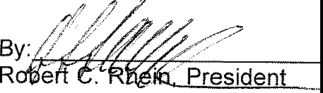

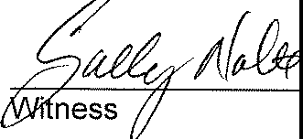

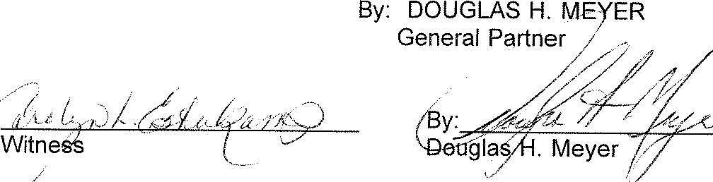



STATE OF OHIO, COUNTY OF HAMILTON, SS:

The foregoing instrument was acknowledged before me this day *J'?' 7 :,,* of

*.:[,wvµv* , 19 *9_,,* by Robert C. Rhein, President of Robert C. Rhein Interests, Inc., an OhioCorporation, one of the partners, on behalf of the Corporation, on behalf of the Partnership.

IN TESTIMONY WHEREOF, I have hereunto subscribed my name and affixed my seal the day and year aforesaid.

STATE OF OHIO, COUNTY OF HAMILTON, SS:

The foregoing instrument was acknowledged before me this day'--'i>st£ of

*,,)1.Jt,:ct,J iii.,* , 19 *,;-;<,* by Douglas H. Meyer, General Partner, one of the partners, on behalf ofthe Partnership.

IN TESTIMONY WHEREOF, I h

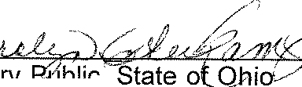

ave hereunto subscribed

d.

,

,

*a*

seal the day and year aforesai

my name and affixed my

( Nata

'---..,./ CAROLYN ESTERKPMP

Notary Pub'ic, State of Ohio

M:. r::Nnmission **Expires Jan. 9, 1997**

This instrument prepared by:

RHEIN-MEYER PARTNERSHIP NO. I

7265 Kenwood Road, Suite 157

Cincinnati, Ohio 45236

(513) 891-7100

F:\HOA\CRYSTAL



###### JOINER IN DECLARATION AND CONSENT TO SUBMISSION

The undersigned, Douglas Homes, an Ohio Corporation, does hereby join in the Crystal Creek Declaration of Covenants, Conditions, Restrictions, Easements and Liens, for the purpose of submitting all lots owned by said corporations to the provisions of the Declaration, By-Laws and Articles of Incorporation for Crystal Creek Homeowners' Association. The undersigned agrees that all lots owned by them shall

hereafter be bound by the terms of the Covenants, Conditions, Restrictions, Easements and Liens for Crystal Creek Homeowners' Association.

_ ..;'

###### Signed and acknowledged: *I*

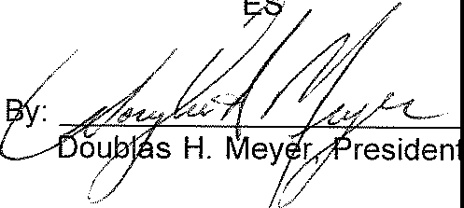

DOUGLAS HOM

*I*

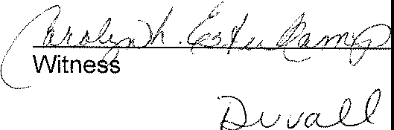

Witness

STATE OF OHIO, COUNTY OF HAMILTON, SS:

The foregoing instrument was acknowledged before me this, *.g;,r,Cday* of

*\./4U'&14,tc,* ,1995by *.bo,q1,,,,, >;;</L/Tlc;_Y'.ce* ofDouglas

###### Homes, arr Ohio Corporation, on behalf of the corporation.

-- , ,

*/ ll 2* ,; *t2);* --, *)<;,z* 2*Y 16. A,./J!f(.*

*//··;* - . *..fa* _./ */.* /)

###### / Notary Public, State of'ehio· ..,7

1'-.. CAROLYN ESTERlv'.'OP

_ ..., [\Jot&ry Pub'.ic, State of Ohio

M:· *(:c* L;it1\ '.sion Expires Jan, 9, 1997



**EXHIBIT "A"**

Situated in Union Township, Clermont County, Ohio in Churchill Jones Military Survey #1134 and being more particularly described as follows:

Lots 1 through 33 as shown on the Record Pia! *pf* Crystal Creek - Block A as recorded in Plat Book -=2_, Pages *1r.* 7 .fn'cr.ID of the Plat Records of Clermont County, Ohio.

Prior instrument: Deed Book 553, Page 329 of the Deed Records of Clermont County, Ohio.

EXHIBIT "B"



ooyer

·becl<er engineers

PARCEL #1

f.age 1 of 4

**865 hla aven&;;;;;**

# milford, ohio 451SO

**{S13) 248-8311**

**fax (513) 248-8314**

BOO 597 1',G co5

##### September 13, 1994

DESCRIPTION: LOCATION:

56.213 Acre Tract

Crystal Creek Subdivision Union Township, Clermont County

Situated in Churchill Jones Military Survey #1134, Union Township, Clermont County, Ohio and being a 56.213 acre tract being further described as follows:

Begin at the intersection of Withamsville Glen Este Road and Shayler Road, thence along the centerline of Shayler Road South 89022'00" East, 655. 75 to an existing p.k. nail, said being the point of beginning:

thence from the point of beginning thus found and departing said centerline North 00050'27" East, passing a set 5/8" iron pin at 20 feet, a total distance of 545.28 feet to a. set 5/8" iron pin;

thence North 89024'05 West, lOQ.93 feet to an existing iron pin;

thence North 01018'55" East, 336.74 feet to an existing iron pin;

thence•:. North 89024'05" .west, 340.00 feet to a set 5/8" iron pin;

thence North 01018"55" East, 214.67 feet to an existing iron pin;

thence South 89024 '05" _East, 100.00 feet to an existing iron pin;

thence North 01018'55" East, 126.05 feet to an existing iron pin;

thence South 89041'05" East, 344.56 feet to a set 5/8" iron pin;

thence North OOo53'53" East, 465.05. feet to a set 5/8" iron pin;

thence South 88050'31" East, 470.09 feet to· a set 5/8" iron pin;

thence

thence

South 89022'47" East, 246.39 feet to an existing stone;·

North 00018'07" E!ist, 265.82 feet to a set 5/8" iron pin;

surve_yors

Page 2 of 4



##### Crystal Creek Subdivision

56.213 Acre Tract Page 2

thence thence

thence thence thence thence

thence thence

thence thence

thence

South 86055'25" East, 811.58 feet to an existing iron pin;

South OOo47'00" East, passing an existing 1/2" iron pin at 1388.70 feet a total distance of 1463.65 feet to an existing 1/2" iron pin;

South 89013'17" West, 100.10 feet to an existing 1/2" iron pin;

South OOo46'43" East, 6.32 feet to a set 5/8" iron pin;

South 73042'17" West, 747.25 feet to a set 5/8" iron pin;

South OOo01'22" West, passing a set 5/8" iron pin

206.42 feet a total distance of 226.42 feet to the centerline of Shayler Road;

along said centerline North 89022'44" West., 25.00 feet to an existing spike;

departing said centerline North OOo Ol'22" East, passing a set 5/8" iron pin at 20 feet a total distance of 612.48 feet to a set **5/8"** iron pin; South 88011'44" West, 430.59 feet to a set 5/8" iron pin;

South 01053•50• West, ·passing **a** set 5/8" iron pin

at 574.37 feet **a** total distance of 594.37 feet to an existing spike, said spike being on the centerline of Shayler Road;

along said centerline Noith 89026'00" West, 282.55 feet to the true point of beginning containing

56.213 acres of land subject to all easements and rights-of-way on record.

"The above described real estate is a part of the same premises described as recorded in Deed Book 720 page 02 of the Clermont County Ohio Deed Records and identified as parcel No. 41- 32-17B-04, 267, 14, 13 on the Tax Maps of said County. Being the result of a survey and plat dated September 12, 1994, made by Jeffrey O. Lambert P.S., Ohio Reg. No. 7568.

PARCEL #2



**boyer becKer engineers**

Page 3 of 4

**865 lila avenue milford, ohio 45 l SO (S13) 248-8311**

**fax (513) 248-8314**

*f.('°'"1*

I':: *r;-,*

BOOV , .. *( y(,' .J j I*

###### September 13, 1994

DESCRIPTION: LOCATION:

9.995 Acre Tract

Crystal Creek Subdivision Union Township, Clermont County

Situated in Churchill Jones Military Survey #1134, Union Township, Clermont County, Ohio and being a 9.995 acre tract being further described **as** follows:

Begin at the intersection of Withamsville Glen Este Road and Shayler Road, thence along the centerline of Shayler Road the next

***4*** cours s: South 89022'00" East, 655.75 feet to an existing p.k.

nail, thence South 89026'00" East, 282.55 feet to an existing spike, thence North 89022'44" East,· 484.05 feet, thence North 73045'00" East, 842.74 feet, thence departing said centerline North 00o44'00" West, 206.88 feet, thence North 00047•00• West, 74.95 feet to an existing 1/2" iron pin, said iron pin also being the true point of beginning:

thence from the point of beginning thus found North 00047•00· West, 1388.70 feet to an existing iron pin;

thence South 87005'56" East, 406.08 feet to an existing iron pin;

thence South 00009'20" West, 1029.57 feet to an existing

|  |  |  |  |  |  |  |  |  |  |  |  |
| --- | --- | --- | --- | --- | --- | --- | --- | --- | --- | --- | --- |
|  | iron pin; | |  | | | | | | | | |
| thence | North 87004'40" | | West, | 339.08 | | feet | | to | an | existing | |
|  | 1/2" iron pin; | |  |  | |  | |  |  |  | |
| thence | South 00047•00• | | East, | 169.22 | | feet | | to | an | existing | |
|  | 1/2" iron pin; | |  |  | |  | |  |  |  | |
| thence | South | a1039,oo• | East, | 33.93 | feet | | to | a | set | 5/8" | iron |
|  | pin; |  |  |  |  | |  |  |  |  |  |
| thence | South | 49044•00• | East, | 62.00 | feet | | to | a | set | 5/8" | iron |
|  | pin; |  |  |  |  | |  |  |  |  |  |
| thence | South | 22052•00• | West, | 79.00 | feet | | to | a | set | 5/8" | iron |
|  | pin; |  |  |  |  | |  |  |  |  |  |
| thence | South | 34055'00" | West, | 82.00 | feet | | to | a | set | 5/8" | iron |
|  | pin; |  |  |  |  | |  |  |  |  |  |

---•-----

##### Page 4 of 4



Crystal Creek Subdivision 9.995 Acre Tract

Page **2**

thence South 89013'00" West, 50.00 feet to the point of beginning containing 9.995 acres of land subject to all easements and rights-of-way on record.

"The above described real estate is a part of the same premises described as recorded in Deed Book 700 page 490 of the Clermont County Ohio Deed Records and identified **as** parcel No. 41- 32-17B-270 on the Tax Maps of said County. Being the result of **a** survey and plat dated September 12, 1994, made by Jeffrey O. Lambert P.S., Ohio *RPg.* No. 7568.

**FIRST AMENDMENT TO THE DECLARATION OF COVENANTS, CONDITIONS, AND RESTRICTIONS FOR**

**CRYSTAL CREEK HOMEOWNERS' ASSOCIATION**

***WHEREAS,*** the Declaration of Covenants, Conditions, and Restrictions for Crystal Creek Homeowners' Association is recorded in Deed Book 597, Page 596 of the Official Records of Clermont County, Ohio (hereinafter "the Declaration), and;

***WHEREAS,*** the Declaration is binding upon all owners of the property described in Exhibit A attached hereto;

***WHEREAS,*** the owners desire to amend the Declaration to provide for fencing restrictions;

***WHEREAS,*** the Declaration, at Article IX, Section 9.2 provides for the Amendment of the Declaration by the approval of owners not exercising less than sixty-seven percent (67%) of the voting power of the entire membership:

***NOW THEREFORE,*** pursuant to Article IX of the Declaration, the Declaration is hereby amended as follows:

1. Article VIII, Section 8.3(D) is hereby deleted and the following substituted in its place:

Section 8.3. Prohibited Uses.

D. Walls or fences to be erected on any lots shall be ornamental in character. Yard fences shall be limited to split rail fences, with mesh optional. No wall or fence shall extend into the front yard beyond the rear line of each respective residence except, however, retaining walls or other walls required by nature of the contour of the lot. Comer lots are declared to have two (2) front building setback lines. On comer lots only, at the sole discretion of the Board of Trustees of Crystal Creek Homeowners' Association, a side-yard fence may be approved to encroach no more than thirty (30) feet from the rear comer of the residence into the building setback located on the side of the residence. Permitted yard fences shall not exceed four (4) feet in height. At the discretion of the Declarant or the Declarant's designee, privacy fences, which shall not exceed six (6) feet in height may be allowed in conjunction with small private areas adjacent to the rear of the single family dwelling, such as a patio, a deck, or a hot tub. At the discretion of the Declarant or the Declarant's designee, privacy fences may also be allowed along any property line, which abuts lots of surrounding developments. These fences shall be limited to cedar, redwood, or treated lumber, be shadow box design, natural in color, limited to six (6) feet in height and must be approved by the Declarant or the Declarant's designee.

All fences erected by Declarant within the common area, open area, fence and landscape shall be exempt from all fencing restrictions.

***IN WITNESS WHEREOF,*** pursuant to Article IX, Section 9.2 of the Declaration, the President and Secretary of Crystal Creek Homeowners' Association do hereby certify that the requisite consent or vote to the Amendment has been obtained from the members of the Association as evident by the attache Exhibit B. This Amendment is executed this_£_ day of /' *,e,6* , 2003.

Witnesses: Crystal Creek Homeowners'

Association

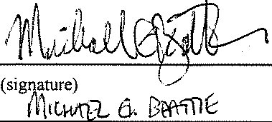



President

(print name)



(s gnat re)

(print name)

B,y

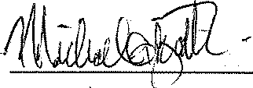

- *i'l*

. l&c\ */f;cttl.fj)/J)*

(**si.a,nature)**

/itlCfi,n"1, fr (

(print name)

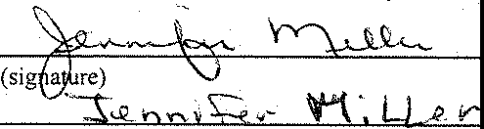

(print name)

STATE OF OHIO )

) **ss:**

COUNTY OF HAMILTON )

--= Secretary

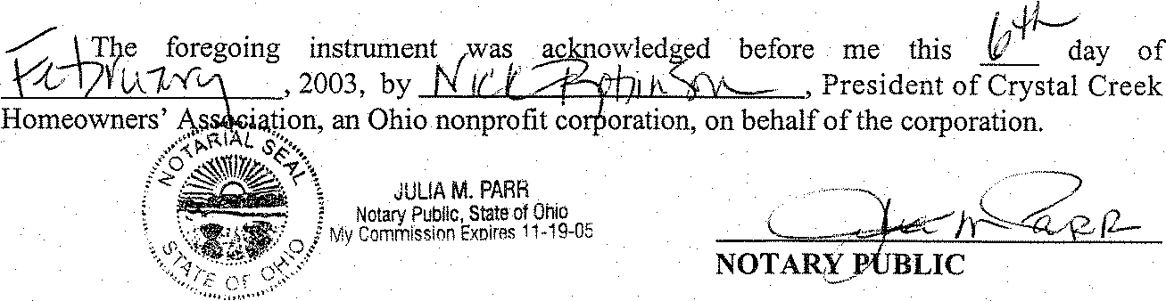

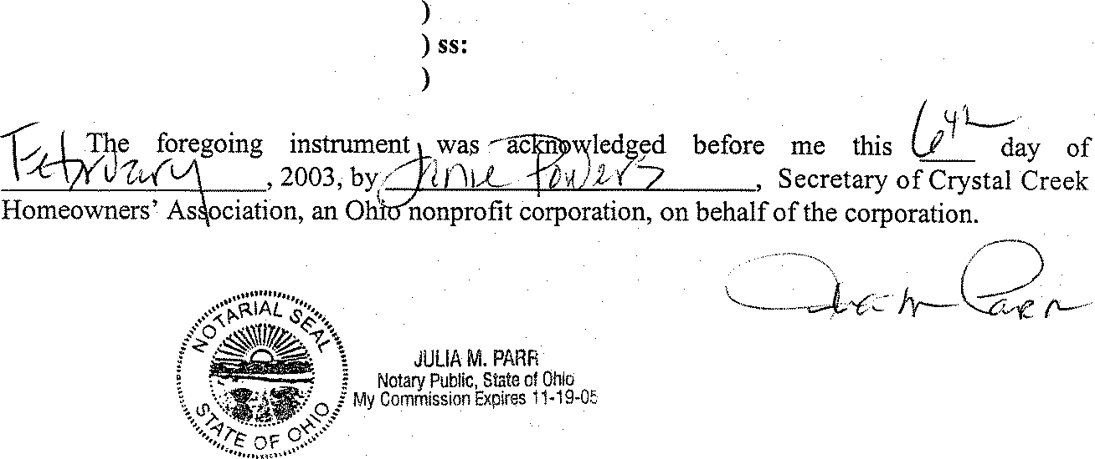

ST ATE OF OHIO

COUNTY OF HAMILTON

NOTARY-PUBLIC

*This Instrument Prepared By:*

*Amy Schott Ferguson*

*Cuni, Ferguson, Wolfgang* & *LeVay Co., L.P.A. 10655 Springfield Pike*

*Cincinnati, Ohio 45215*

Exhibit A

STATE OF OHIO COUNTY OF HAMILTON

) **AFFIDAVITOFTHESECRETARYOF**

) **CRYSTAL CREEK HOMEOWNERS'**

) **ASSOCIATION**

)

Now comes the Affiant, being duly sworn and cautioned, and hereby states as follows:

1. I am the duly elected Secretary of Crystal Creek Homeowners' Association.
2. Pursuant to Article IX, Section 9.2 of the Declaration, sixty-seven percent (67%) of the Unit owners entitled to exercise the voting power of the Association have approved this Amendment.

***Further Afjiant Sayeth Naught.***

*BGovu* ,*r W,t(l..{.Ju;!)*

_·_*T*..,*7*..*T ,* Secretary

STATE OF OHIO )

**)SS:**

**COUNTY OF HAMILTON** )

The foregoing Affidavit was sworn to and subscribed before me by the Secretary of Crystal Creek Homeowners' Association, an Ohio nonprofit corporation, on behalf of the corporation

this (J l"day off tbfJ ?L-fv\ , 2003. .. ···- \'- - .

".', \L;,ce<:.../. !er::::

*I*

**Notary Publijl'**

I... ···

•···c/ac::\ V*ye..,..---·*





EXHIBIT "C"

BY-LAWS AND REGULATIONS OF CRYSTAL CREEK HOMEOWNERS' ASSOCIATION

Prepared By:

RHEIN-MEYER PARTNERSHIP NO. I

7265 Kenwood Road, Suite 157

Cincinnati, Ohio 45236



TABLE OF CONTENTS

ITEM PAGE NO.

ARTICLE I 1

1.1 Name and Location 1

ARTICLE II. 1

Definitions 1

##### 2.1 .........................................................1

2.2 .........................................................1

ARTICLE Ill 1

Meeting of Members 1

* 1. Annual Meeting 1
  2. Special Meetings 1
  3. Notice of Meetings 2
  4. Quorum 2
  5. Adjourned Meetings 2
  6. Proxies 2
  7. Voting 2
  8. Suspension of Voting Privileges 2

ARTICLE IV 3

Board of Trustees; Selection; Term of Office 3

* 1. Number 3
  2. Term of Office 3
  3. Removal 3
  4. Compensation 3
  5. Action Taken Without a Meeting 3

ARTICLE V 4

Nomination and Electrion of Trustees. 4

* 1. Nomination 4
  2. Election 4

ARTICLE VI. 4

Meetings of Trustees 4

6.Regular Meetings 4

* 1. Special Meetings 4
  2. Quorum 4

TABLE OF CONTENTS

ITEM PAGE NO.

ARTICLE VII 5

Power and Duties of the Board of Trustees 5

7.1 Powers 5

1. .Duties 5

ARTICLE VIII 7

Officers and Their Duties 7

* 1. Enumeration of Officers 7
  2. Election of Officers 7
  3. Term 7

1. .Special Appointments 7

8.5 Resignation and Removal 7

8.Vacancies 7

8.7 Multiple Offices 7

8.Duties 7

ARTICLE IX. 8

Committees 8

ARTICLE **X** 9

Miscellaneous 9

* 1. Books and Records 9
  2. Fiscal Year 9
  3. Execution of Association Documents 9
  4. Conflict 9
  5. Amendments 9

ii

EXHIBIT "C" 

BY-LAWS AND REGULATIONS OF

CRYSTAL CREEK HOMEOWNERS' ASSOCIATION

ARTICLE I

Section 1.1. Name and Location. The name of the corporation is Crystal Creek Homeowners' Association, hereinafter referred to as "Association". The principal office of the corporation shall be located at Suite 157, 7265 Kenwood Road, Cincinnati, Ohio 45236, but meetings of members and trustees may be held at such places within Clermont County, State of Ohio, as may be designated by the Board of Trustees.

ARTICLE II

DEFINITIONS

Section 2.1. "Declaration" shall mean and refer to the Declaration of Covenants, Conditions, Restrictions, Easements and Liens applicable to the Properties recorded in the office of the Clermont County Recorder, and appended to the Articles of Incorporation, as the same may be amended, from time to time.

Section 2.2. As used in these Regulations, the terms "Articles", "Association", "Board", "By-Laws", "Common Areas", "Declarant", "Developer", "Living Unit", "Lot", "Member", "Owner", and "Property", shall have the same meaning as each is defined to have in the Declaration.

ARTICLES **Ill**

MEETING OF MEMBERS

Section 3.1. Annual Meeting. The first annual meeting of the members shall be held on the .res'.liilillflllm 'fl,il\Ystcelll,::s'lii@i and each subsequent regular annual meeting of the Members shall be held on the second Thursday of March of each year thereafter, at the hour of 7:30 o'clock p.m.

Section 3.2. Special Meetings. Special meetings of the members may be called at any time by the President or by the Board of Trustees, or upon written request of the Members who are entitled to vote one-third (1/3) of all the votes of membership.

Section 3.3. Notice of Meetings. Except as otherwise provided in the Declaration, written notice of each meeting of the Members shall be given by, or at the direction of the Secretary or person authorized to call the meeting, by mailing or delivering a copy of such notice, at least fifteen (15) days before such meeting, to each Member entitled to vote thereat, addressed to the Member's address last appearing on the books of the Association, or supplied by such Member to the Association for the purpose of notice. Such notice shall specify the place, day and hour of the meeting, and, in case of a special meeting, the purpose of the meeting.

Section 3.4. Quorum. The presence at the meeting of Members entitled to cast, or,'1f¼f! /l:t'ft e9SiiEl!'l flel'l 10t'!,'* "' l" n t0 '01!!JdJ'1!l-e,, ri 17ifflt tf1tr hffl ffl!J rs1",'fp

shall constitute a quorum for any action except as otherwise provided in the Articles of Incorporation, the Declaration or these By-Laws and Regulations. If however, such quorum shall not be present or represented at any meeting, the Members entitled to vote thereat shall have the power to adjourn the meeting from time to time, without notice other than announcement at the meeting, until a quorum as aforesaid shall be present or be represented.

Section 3.5. Adiourned Meetings. If, at any regular or special meeting of the Members of the Association, there be less than a quorum present, a majority of those Members present and entitled to vote may adjourn the meeting to a time not less than forty-eight (48) hours from the time the original meeting was called, at which

time the qu?ru.n;.reqLli, i i fi i:llftbb.@l,® B11im0%( itS, W 0'ffiffi ti!'2 Wi 7 ffl' m'S!gf 'ip

'®'Mlil•17A - 1'o'1, and any business which might lawfully have been transacted at the meeting as originally called may be transacted without further notice.

Section 3.6. Proxies. At all meetings of the Members, each Member may vote in person or by proxy. All proxies shall be in writing and filed with the Secretary.

Every proxy shall be revocable and shall automatically cease upon conveyance by the Member of his Lot.

Section 3.7. Voting. The vote of the majority of those present, either in person or by proxy, shall decide any questions brought before the meeting, unless the question is one upon which a different vote is required by provision of the laws of Ohio, the Declaration, the Articles of Incorporation of the Association or these

By-Laws and Regulations.

Section 3.8. Suspension of Voting Privileges. No member shall be eligible to vote or to be elected to the Board of Trustees who is shown on the books of the Association to be more than thirty (30) days delinquent in the payment of any assessment due the Association.



ARTICLE IV

BOARD OF TRUSTEES; SELECTION; TERM OF OFFICE

Section 4.1. Number. The affairs of this Association shall be managed by a Board of Five (5) Trustees who, except for Trustees appointed or elected by Declarant, shall be members of the Association.

Section **4.2.** Term of Office; Resignations. Each Trustee shall hold office for **a** term of two years and until his successor is elected, until his earlier resignation, or removal from office or death, except that at the first Annual Meeting three members of the original Board of Trustees, two of whom shall be appointed by the Declarant and one of whom shall be elected by the members of the Association other than the Declarant, shall serve for a term of two years and the other two members of the Board of Trustees, one of whom shall be appointed by the Declarant and one of whom shall be elected by the members of the Association other than the Declarant, shall serve for a term of one year. The successors of the orignal Trustees whose terms expire after the first year shall serve thereafter for a term of two years.

However, as long as Declarant shall remain a Class "B" member of the Association Declarant reserves the right to appoint the successor to any Trustee appointed by Declarant. Any Trustee may resign at any time by oral statement to that effect made at a meeting of the Board of Trustees or in writing to that effect delivered to the Secretary of the Association; such resignation shall take effect immediately or at such other time as the Trustee may specify.

Section 4.3. Removal. Any Trustee may be removed from the Board, with or without cause, by a majority vote of the members of the Association. In the event of death, resignation or removal of a Trustee, his successor shall be selected by the remaining Members of the Board and shall serve for the unexpired term of his predecessor. However, any Trustee elected or appointed by the Declarant may only be removed by the Declarant, and his successor may only be appointed by Declarant, to serve for the unexpired term.

Section 4.4. Compensation. Members of the Board of Trustees shall serve without compensation. However, any Trustee may be reimbursed for his actual expenses incurred in the performance of his duties.

Section 4.5. Action Taken Without a Meeting. The Trustees shall have the right to take any action in the absence of a meeting which they could take at a meeting by obtaining the written approval of all the Trustees. Any action so approved shall have the same effect as though taken at a meeting of the Trustees.



ARTICLE V

NOMINATION AND ELECTION OF TRUSTEES

Section 5.1. Nomination. Nomination for election to the Board of Trustees shall be made by a Nominating Committee. Nominations may also be made from the floor at the annual meeting. The Nominating Committee shall consist of a Chairman, who shall be a member of the Board of Trustees, and two or more members of the Association. The Nominating Committee shall be appointed by the Board of Trustees 60 days prior to each annual meeting of the members, to serve from the time of appointment until the close of the next annual meeting, and such appointment shall be announced at the next regular Board meeting. The Nominating Committee shall make as many nominations for election to the Board of Trustees as it shall in its discretion determine, but not less than the number of vacancies that are to be filled.

Section 5.2. Election. Election to the Board of Trustees shall be by secret written ballot. At such election the members or their proxies may cast, in respect to each vacancy, as many votes as they are entitled to exercise under the provisions of the Declaration and Section 3.7 of Article Ill of these By-Laws and Regulations. The persons receiving the largest number of votes shall be elected. Cumulative voting is not permitted.

ARTICLE VI

MEETINGS OF TRUSTEES

Section 6.1. Regular Meetings. The Board of Trustees shall meet annually within 10 days after the annual meeting of members and, in addition to the annual meeting, shall meet at regular meetings established as to time and place by resolution of the Board. Should any regular meeting fall upon a legal holiday, then that meeting shall be held at the same time on the next day which is not a legal holiday.

Section 6.2. Special Meetings. Special meetings of the Board of Trustees shall be held when called by the President of the Association, or by any two (2) Trustees, after not less than three (3) days notice to each Trustee.

Section 6.3. Quorum. A majority of the number of Trustees shall constitute a quorum for the transaction of business. Every act or decision done or made by a majority of the Trustees present at a duly held meeting at which a quorum is present shall be regarded as the act of the Board.



ARTICLE VII

POWERS AND DUTIES OF THE BOARD OF TRUSTEES

Section 7.1. Powers. The Board of Trustees shall have power to:

1. adopt and publish rules and regulations governing the use of the Common Areas and the personal conduct of the members and their guests thereon, and to establish penalties for the infraction thereof;
2. suspend the voting rights and right to use of the Common Areas of a member during any period in which such member shall be in default in the payment of any assessment levied by the Association. Such rights may also be suspended after notice and hearing, for a period not to exceed thirty (30) days, for infraction of published rules and regulations;
3. exercise for the Association all powers, duties and authority vested in or delegated to this Association and not reserved to the membership by other provisions of these By-Laws and Regulations, the Articles of Incorporation, or the Declaration;
4. declare the office of a member of the Board of Trustees to be vacant in the event such member shall be absent from three (3) consecutive regular meetings of the Board of Trustees; and
5. employ such independent contractors, and other employees as they deem necessary, and to prescribe their duties.

Section 7.2. Duties. It shall be the duty of the Board of Trustees to:

1. cause to be kept a complete record of all its acts and corporate affairs and to present a statement thereof to the members at the annual meeting of the Members, or at any special meeting when such statement is requested in writing by one-fifth (1/5) of each class of Members who are entitled to vote;
2. supervise all officers, agents and employees of this Association, and to see that their duties are properly performed;
3. as more fully provided in the Declaration, to
   1. fix the amount of the annual assessment against each Lot at least thirty

(30) days in advance of each annual assessment period;



1. send written notice of each assessment to every Owner subject thereto at least fifteen (15) days in advance of each annual assessment period; and
2. foreclose the lien against any Lot for which assessments are not paid within sixty (60) days after due date or bring an action at law against the Owner personally obligated to pay the same, if the Board deems foreclosure or other action necessary.
3. issue, or cause an appropriate officer to issue, upon demand by any person, a certificate setting forth whether or not any assessment has been paid. A reasonable charge not to exceed fifteen dollars ($15.00), may be made by the Board for the issuance of these certificates. If a certificate states an assessment has been paid, such certificate shall be conclusive evidence of such payment;
4. procure and maintain adequate liability and hazard insurance on property owned by the Association;
5. cause all officers having fiscal responsibilities to be bonded, as required by the Declaration; and
6. cause the Common Areas and Landscape Easements to be maintained.

 

ARTICLE VIII

OFFICERS AND THEIR DUTIES

Section 8.1. Enumeration of Officers. The officers of this Association shall be a President and Vice-President, who shall at all times be members of the Board of Trustees, a Secretary, and a Treasurer, and such other officers as the Board may from time to time by resolution create.

Section 8.2. Election of Officers. The election of officers shall take place at the first meeting of the Board of Trustees following each annual meeting of the members.

Section 8.3. Term. The officers of this Association shall be elected annually by the Board and each shall hold office for one (1) year and until his successor is elected and qualified, unless he shall sooner resign, or shall be removed or otherwise disqualified to serve.

Section 8.4. Special Appointments. The Board may elect such other officers as the affairs of the Association may require, each of whom shall hold office for such period, have such authority and perform such duties as the Board may, from time to time, determine.

Section 8.5. Resignation and Removal. Any officer may be removed from office with or without cause by the Board. Any officer may resign at any time by giving written notice to the Board, the President or the Secretary. Such resignation shall take effect on the date of receipt of such notice or at any later time specified therein, and unless otherwise specified therein, the acceptance of such resignation shall not be necessary to make it effective.

Section 8.6. Vacancies. A vacancy in any office may be filled by appointment by the Board. The officer appointed to such vacancy shall serve for the remainder of the term of the officer he replaces.

Section 8.7. Multiple Offices. The office of Secretary and Treasurer may be held by the same person. No person shall simultaneously hold more the one of any of the other offices except in the case of special offices created pursuant to Section 8.4 of this Article.

Section 8.8. Duties. The duties of the officers are as follows:

1. President - The President shall preside at all meetings of the Board of Trustees; shall see that orders and resolutions of the Board are carried out; and shall act as chief executive officer.



1. Vice-President - The Vice-President shall act in the place and stead of the President in the event of his absence, inability or refusal to act, and shall exercise and discharge such other duties as may be required by him by the Board.
2. Secretary - The Secretary shall record the votes and keep the minutes of all meetings and proceedings of the Board and of the members; serve notice of meetings of the Board and of the members; keep appropriate current records showing the members of the Association together with their addresses, and shall perform such other duties as required by the Board.
3. Treasurer - The Treasurer shall receive and deposit in appropriate bank or savings and loan accounts all monies of the Association and shall disburse such funds as directed by resolution of the Board of Trustees; keep proper books of accounts; cause an annual reviews of the Association books to be made by a public accountant at the completion of each fiscal year; and shall prepare an annual budget and a statement of income and expenditures to be presented to the membership at its regular annual meeting, and deliver a copy of each to the members.

ARTICLE IX

COMMITTEES

The Board of Trustees shall appoint a Nominating Committee, as provided in these By-Laws and Regulations. In addition, the Board of Trustees shall appoint other committees as deemed appropriate in carrying out its purposes.



ARTICLE X

MISCELLANEOUS

Section 10.1. Books and Records. The books, records and papers of the Association shall at all times, during reasonable business hours, be subject to inspection by any member, and any holder, insurer or guarantor of a first mortgage on a Lot. The Declaration, the Articles of Incorporation and the By-Laws and Regulations of the Association shall be available for inspection by any member at the principal office of the Association, where copies may be purchased at reasonable cost.

Section 10.2. Fiscal Year. The fiscal year shall begin on the first day of January every year, except that the first fiscal year of the Association shall begin on the date of incorporation. The commencement date of the fiscal year herein established may be changed by the Board of Trustees should corporate practice subsequently dictate.

Section 10.3. Execution of Association Documents. All notes, contracts, other documents, checks, and other drafts shall be executed on behalf of the Association by such officers, agents or other persons as are from time to time designated by the Board of Trustees.

Section 10.4. Conflict. In the case of any conflict between the Articles of Incorporation and the By-Laws and Regulations, the Articles shall control; and in the case of conflict between the Declaration and these By-Laws and Regulations, the Declaration shall control.

Section 10.5. Amendments. These By-Laws and Regulations may be amended at a regular or special meeting of the members, by affirmative vote of a majority of the total number of votes held by each class of Members of the Association.

F:HOA\CRYSTALC



EXHIBIT "D"

ARTICLES OF INCORPORATION OF CRYSTAL CREEK HOMEOWNERS' ASSOCIATION

Prepared by:

RHEIN-MEYER PARTNERSHIP NO. I

7265 Kenwood Road, Suite 157

Cincinnati, Ohio 45236



TABLE OF CONTENTS

ITEM PAGE NO.

ARTICLE I 1

Name 1

ARTICLE **II** 1

Location 1

ARTICLE **Ill** 1

Pu e 1

ARTICLE IV 3

Trustees 3

ARTICLE V 3

Membership 3

ARTICLE VI. 4

ingR 4

ARTICLE VII 4

Dissolution 4

ARTICLE VIII. 5

Duration 5

ARTICLE **IX.** 5

Amendments 5

ARTICLE **X** 5

Dealing with Corporation 5

ARTICLE XI. 6

Indemnification of Trustees, Officers or Employees 6

ARTICLES OF INCORPORATION

OF

CRYSTAL CREEK HOMEOWNERS' ASSOCIATION

The undersigned, desiring to form a corporation not for profit, under the Ohio Non-Profit Corporation Law, Section 1702.01 to 1702.58, inclusive, of the Revised Code of Ohio, does hereby certify:

ARTICLE I

The name of the corporation shall be Crystal Creek Homeowners' Association.

ARTICLE II

The place in the State of Ohio where the principal office of the corporation is to be located is in Union Township, Clermont County, Ohio.

ARTICLE Ill

The purpose for which said non-profit corporation is formed, and various other provisions pertaining to this non-profit corporation and its powers are set forth in the following sections of these Articles. This non-profit corporation, hereinafter sometimes referred to as the "Association", does not contemplate pecuniary gain or profit to the members thereof, and the specific purposes for which it is formed are to act as the Lot Owners' Association with regard to the tracts of real estate specifically described in the Declaration of Covenants, Conditions and Restrictions applicable to said real estate, said Declaration being recorded or to be recorded in the property records of the county where the principal office of this corporation is located. In addition, the specific purposes for which this Association is formed are to provide for the maintenance, preservation and control of the aforesaid real estate and the buildings and improvements situated thereon under the terms of said Declaration, and to promote the health, safety and welfare of the residents and owners of the above described property and to act in the same manner with regard to any other property which may hereafter be brought within the jurisdiction of this Association as part of the same plan, and for these purposes:

1. to exercise all the power and privileges and to perform all of the duties and obligations of the Association as set forth in the aforesaid Declaration or as the same may be amended from time to time;
2. to fix, levy, collect and enforce payment by any lawful means of all charges



or assessments pursuant to the terms of the Declaration; to pay all expenses in connection therewith and all office, administrative, and other expenses incident to the conduct of the business of the Association, including all license fees, taxes or governmental charges levied or imposed against the property of the Association;

1. to acquire (by gift, purchase or otherwise), own, hold, improve, build upon, operate, maintain, convey, sell, lease, transfer, dedicate for public use or otherwise dispose of real or personal property in connection with the affairs of the Association and subject to the terms of the Declaration;
2. to borrow money, and with the assent of a majority of the voting power of the Association, to mortgage, pledge, deed in trust, or hypothecate any or all of its real or personal property as security for money borrowed or debts incurred, but only to the extent permitted by the Declaration;
3. to dedicate, sell or transfer all or any part of the Common Areas to any public agency, authority or utility for such purpose and to the extent and in such manner as may be authorized in the Declaration;
4. to own, acquire, build, operate and maintain Common Areas, Open Spaces, private utility lines and landscape easements, and any structures, fixtures and all personal property incidental thereto, in accordance with the Declaration;
5. to obtain, pay for and maintain insurance to the extent provided in the Declaration;
6. to do any other thing necessary, expedient, incidental, appropriate or convenient to the carrying out of the foregoing purposes or which will promote the common benefit and enjoyment of the residents or owners of the Lots, insofar as not prohibited by law or the Declaration; and
7. to have and to exercise any and all powers, rights and privileges which a corporation organized under the Non-Profit Corporation Law of the State of Ohio by law may now or hereafter have or exercise, insofar as not prohibited by the Declaration.

ARTICLE IV TRUSTEES

The affairs of this Association shall be managed by the Board of Trustees, sometimes referred to as Directors, who need not be members of the Association. The number of trustees may be designated as not less than three (3) nor more than five (5) members by said Association. The names and addresses of the

persons who are to act in the capacity of initial Trustees until the selection of their successors are:

Name Term of Office Address

David W. Reibold

Steve Bosse

Robert C. Rhein

Thru 1996 Annual

Meeting

Thru 1996 Annual

Meeting

Thru 1996 Annual

Meeting

7265 Kenwood Road,

Suite 157

Cincinnati, Ohio 45236

7265 Kenwood Road,

Suite 157

Cincinnati, Ohio 45236

7265 Kenwood Road,

Suite 157

Cincinnati, Ohio 45236

ARTICLE V

MEMBERSHIP

Every Owner of a Lot as described in the Declaration and as created by that Declaration which is subject by covenants of record contained in the Declaration to assessment by the Association, including purchasers on land installment contract as such instruments are defined in Ohio Revised Code Chapter 5313, and including contract sellers on other forms of executory contracts for the sale of a Lot, but excluding those holding record title or a similar interest merely as security for the performance of an obligation, shall automatically on acquisition of such ownership interest in a Lot be a member of the Association. Membership shall be appurtenant to and may not be separated from ownership of any Lot which is subject to assessment. Such membership shall terminate upon the sale or other disposition by such Lot Owner of his ownership interest, at which time the new Lot Owner shall automatically become a member of the Association.



ARTICLE VI

VOTING RIGHTS

The Association shall have two classes of voting membership:

Class A - Class A members shall be all owners (with exception of the Declarant for as long as Class B membership exists), who shall be entitled to one vote for each lot owned. When more than one person holds an interest in any Lot, all such persons shall be members. The vote for such Lot shall be exercised as set forth in the Declaration and By-Laws.

Class B - Class B members shall be the Declarant (as defined in the Declaration), and such member shall be entitled to a such number of votes as will constitute seventy-five percent (75% ) of the total voting power of the Association, as long as the Class B membership continues to exist. The Class B membership shall cease and be converted to Class A membership with one (1) vote for each Lot owned, on the happening of the following events, whichever occurs earlier:

1. When all of the real property described in Exhibit "B" has been annexed to the Declaration by the Declarant and seventy-five percent (75%) of the Lots therein (up to a total of 100 Lots) have been sold by Declarant and conveyed to individual owners;
2. Seven (7) years from and after the date this Declaration is recorded. Provided, however, that nothing herein shall be construed to prohibit the Class B member from converting all or part of its Class B membership to Class A membership with the results set forth above at any time earlier than the latter of the alternative events referred to above, by a written statement executed by the Declarant and delivered to the Association.

ARTICLE VII

DISSOLUTION

Upon dissolution of the corporation, any assets remaining after payment or adequate provision for payment of all debts and obligations of the corporation shall be expended in furtherance of the purposes set forth herein. If no successor in interest to the corporation is formed to administer the property of the corporation, its assets shall be distributed equally to its members according to a plan adopted and administered by the Board of Trustees.



ARTICLE VIII

DURATION

The corporation shall exist perpetually, unless dissolved earlier under the terms of these Articles.

ARTICLE IX

AMENDMENTS

Amendments of these Articles shall require the assent of members holding at least sixty-seven percent (67%) of the voting power of each class of the Association, except as may be provided to the contrary in the Declaration.

ARTICLE X

DEALING WITH CORPORATION

A director or officer of the corporation shall not be disqualified by his office from dealing or contracting with the corporation as a vendor, purchaser, employee, agent or otherwise; nor shall any transaction, contract or act of the corporation be void or voidable or in any way effected or invalidated by reason of the fact that any director or officer or any firm of which such director or officer is a member, or any corporation of which such director or officer is a shareholder, director or officer, is in any way interested in such transaction, contract or act; provided, however, that the fact that such director, officer, firm or corporation is so interested must be disclosed to or known by the Board of Trustees or such members thereof as shall be present at the meeting of said Board at which action is taken upon such matters. No director or officer shall be accountable or responsible to the corporation for or in respect to any such transaction, contract, or act or for any gains or profits realized by him or by any organization affiliated with him as a result of such transaction, contract or act. Any such director or officer may be counted in determining the existence of a quorum at any meeting of the Board of Trustees of the corporation which shall authorize or take action in respect of any such contract, transaction or act, and may vote to authorize, ratify or approve any such contract, transaction or act, with like force and effect as if he or any firm of which he is a member or a corporation of which he is a shareholder, officer or director, were not interested in such transaction, contract or act.



ARTICLE XI

INDEMNIFICATION OF TRUSTEES, OFFICERS OR EMPLOYEES

The corporation shall indemnify any and every trustee. officer or employee against expenses, judgments. decrees, fines. penalties or amounts paid in settlement in connection with the defense of any pending or threatened action, suit or proceeding, criminal or civil, to which such trustee, officer or employee is or may be made a party by reason of being or having been such trustee, officer or employee. provided a determination is made by the trustees in the manner set forth in Ohio Revised Code Section 1702.12(e) (1) to the effect (a) that such trustee. officer or employee was not. and has not been adjudicated to have been, negligent or guilty of misconduct in the performance of his duty to the corporation of which he is a trustee. officer or employee, (b) that he acted in good faith in what he reasonable believed to be the best interest of such corporation, and (c) that, in any matter the subject of a criminal action. suit or proceeding, he had no reasonable cause to believe that his conduct was unlawful. Such indemnification shall not be deemed exclusive of any other rights to which such trustee, officer or employee may be entitled under these Articles. the By-Laws of this corporation, any agreement or any insurance purchased by this corporation, or by vote of the members. or otherwise.

IN WITNESS WHEREOF. for the purpose of forming this corporation under the laws of the State of Ohio the undersigned lncorporator of this Association has executed these Articles of Incorporation on this..;b-m day of *J,i,,,.tu-/Jrlt.-../* , 19

*9*





ORIGINAL APPOINTMENT OF AGENT

The undersigned, being the lncorporator of Crystal Creek Homeowners' Association, hereby appoints Robert C. Rhein, a natural person resident in the State of Ohio, upon whom any process, notice or demand required or permitted by statute to be served upon the corporation may be served. His complete address is 7265 Kenwood Road, Suite 157, Cincinnati, Ohio 45236.

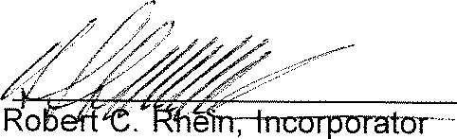

Cincinnati, Ohio

*_),4-;,.( k?f.* 1995

###### CRYSTAL CREEK HOMEOWNERS' ASSOCIATION

Gentlemen:

I hereby accept appointment as agent of your corporation upon whom process, tax notices or demands may be served.

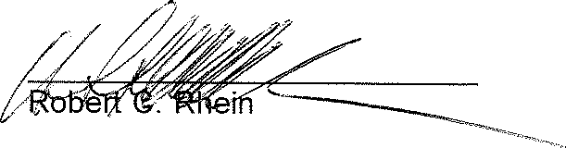

F:HOA\CRYSTALD

Page 1 of 2

EXHl31T "E"

Mailbox regulation pursuant to Section 8.3L of Article VIII of the Declaration for

Crystal Creek



.,

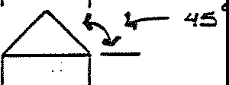

*(,,*

------<

::,/,;• De.a?

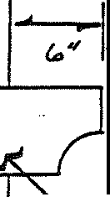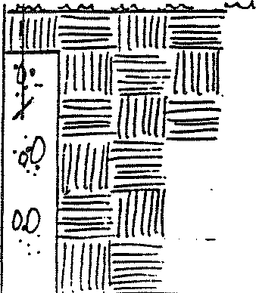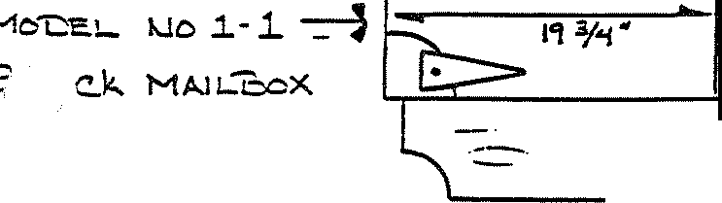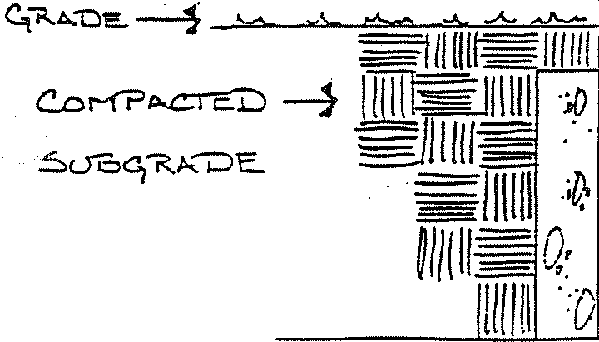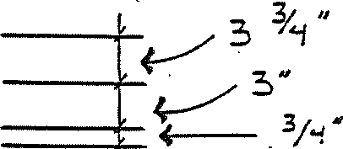

Kc..rran uc:,,c..t-1

#### C.Eu.c..;;,_ - - - .}

|  |  |
| --- | --- |
| ··--- ·.·, | ==-·-=-- |
|  |
| ----- | |
|  | |

?,.ocF==

JCTE.

##### 123.;

l

• •

##### . •

• •

'-.-*S*

*<:,A.*

*•--­*

*-Pc:=.'T* i f-!ot.)6E. ·

Cove:;1,." To oE. +1_ ;3;._o ;_:3/2.;;;.8_•-

.ST A.I l,,Je.u -

OLYM-PtK



G:,>' *C,,* C.'Ei:) A.-;:.. tb::::. I 

*(* W'E.::.-.--e:..-;;1..f..l 1' ED *)*

*/11 ,:/ .UAII..$* _

C..o i..J C..i?..E'i"'E,_ --

**Page** 2 of 2





MouE.L 1uc. 1.-.L

-=,LA-C..K MA.IL°box.

### _.,_

i.X SiuE:, ; MOc..>'-ITti-...1

#### i::ioA. 'D

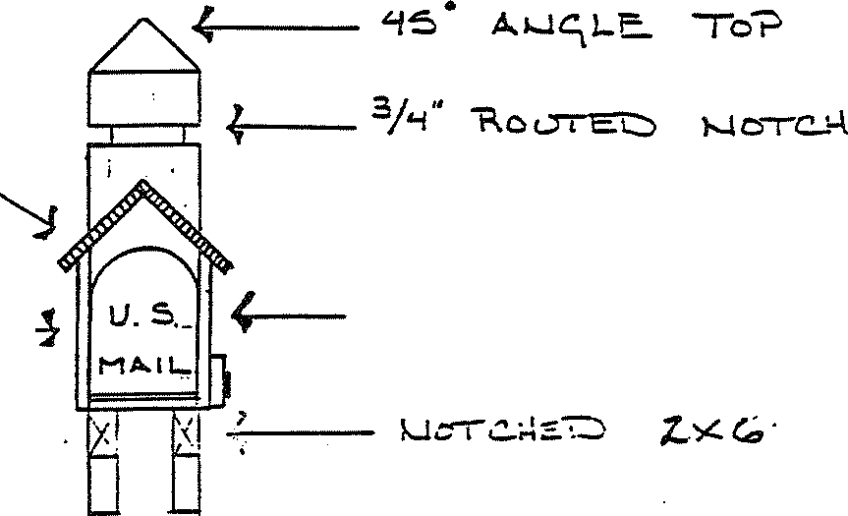

*l:,*:X *l:,* VE :.•E.Rl-..l ----

C.::0 A. -Po:ST

_ , . ===ff11Ilf

UIIU 1

T-h-::.--r *i* Hoc.:> E:.. "P,.ooF

*To* oE. -::$1A.11,.1E.1'.J

01...'r'M?aC.. - OXFoR'"D Or-ow

.--- C.Ou E I E.

1 , 11 11r , ---

* 11lHl lTii1f

§1/1111 ··

*iw1111 J.'..*

= =

-=

i),

*0 :=mm*

*·,D* 11111!

*·o·* =ff

*=*

## . 1111111

*n'=*

. *C.Or-1?*A.C:r i::..0

*.::,L> <;-.:.* A.we:.